2. ReactJS-HOL

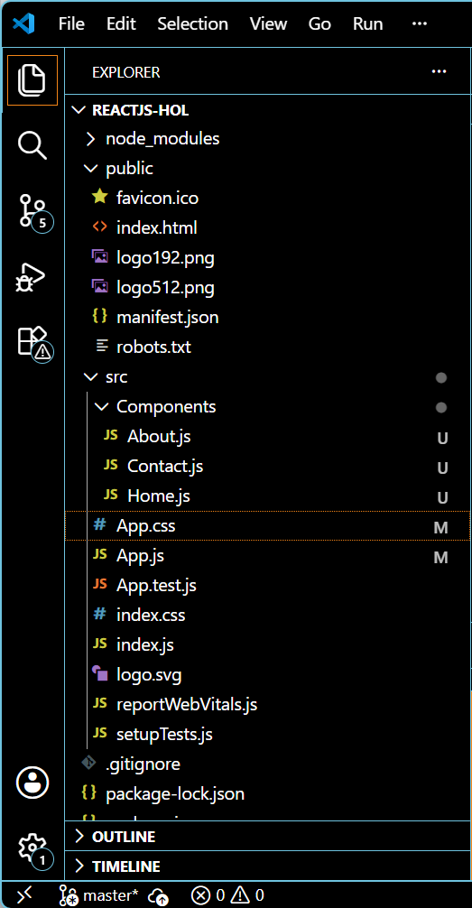

Home.js
import React from 'react';

function Home() {
return (
<div>
<h2>Welcome to the Home page of Student Management Portal</h2>
</div>
);
}

export default Home;

About.js
import React from 'react';
function About() {
return (
<div>
<h2>Welcome to the About page of the Student Management Portal</h2>
</div>
);
}

export default About;

Contact.js
import React from 'react';
function Contact() {
return (
<div>
<h2>Welcome to the Contact page of the Student Management Portal</h2>
</div>
);
}

export default Contact;

App.js
import React from 'react';
import Home from './Components/Home';
import About from './Components/About';
import Contact from './Components/Contact';
function App() {
return (
<div className="App">
<Home />
<About />
<Contact />
</div>
);
}

export default App;
App.css
.App {
text-align: center;
margin-top: 50px;
background-color: #f8f8f8;
min-height: 100vh;
padding: 40px;
}
h2 {
font-size: 1.5rem;
font-weight: bold;
margin: 20px 0;
color: #333;
}
OUTPUT:
